# Project Proposal

## Introduction and Background

“In recent years, health problems, particularly mental health of students is so interested. College is an important setting in which to evaluate and address mental health.”

(Nami et al., 2014)

Today’s society has recently begun speaking out on controversial and sensitive subjects become part of a regular conversation. This has started to include objects such as mental health and wellbeing including the diagnosis that many students who are at university having a mental health condition such as depression and anxiety disorders.

Many students starting at university are now facing the issue where they are unable to find support or unaware of any of the mental health support mechanisms available at their university.

## Aim

The main aim of this project is to design and create a mobile application that allows students at Birmingham City University be able to see the mental health support available from both the university and the students within the university.

The app will also allow them to refer themselves to the Mental Health and Wellbeing student services team within the university and book and appointment with a mental health and wellbeing advisor.

## Objectives

The mobile app needs to be able to follow the Apple iOS Human Interface Guidelines as I will be primarily developing the app on the iOS mobile platform. Apple’s software design guidelines state:

“Three primary themes differentiate iOS from other platforms:

* Clarity. Throughout the system, text is legible at every size, icons are precise and lucid, adornments are subtle and appropriate, and a sharpened focus on functionality motivates the design…
* Deference. Fluid motion and a crisp, beautiful interface help people understand and interact with content while never competing with it…
* Depth. Distinct visual layers and realistic motion convey hierarchy, impart vitality, and facilitate understanding…”

(Apple Inc, 2016)

I will originally design the app so it will work on iPhones and iPods however in future I may include iPads into my designs and there is a possibility to expand the deployment of this application to work with Android devices.

The app must be able to work within the university’s own file and data entry systems including the Microsoft SharePoint platform. This is used by the Student Mental Health and Wellbeing services within the university to allow students to refer themselves to the department. The implementation of this is not very good as many students have to be referred to the actual form by a member of staff and to find this form on iCity, the university’s information portal for staff and students, can be incredibly difficult which could potentially put off students from filling the referral form.

Figure one shows the current menu for the iCity information portal. As you can see, the ability to view the mental health and wellbeing page is not there however after several minutes of clicking you will be able to access the page by clicking several hyperlinks on many pages. Personally, as I have accessed this page previously, I am able to access it within a matter of minutes with only four clicks however some new students who are not used to the layout of iCity may not be able to do so in a similar fashion.

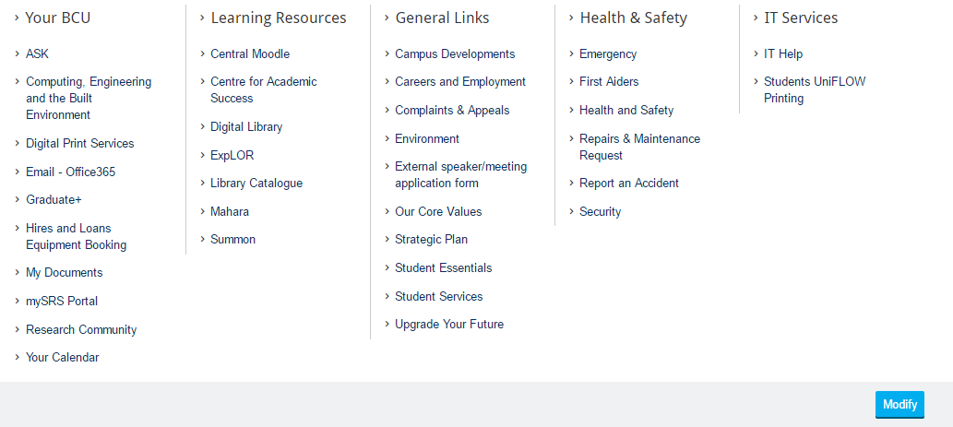

Source: (Birmingham City University, 2015)

Figure 1 – Current BCU iCity Menu System

The app must also be able to allow members of staff to create, amend and cancel appointments for students. This can be done in an administrative section of the app which will be linked to the same database as the student section. There is also the possibility to include the Doodle Online Appointment Management system into this as Doddle allows people to suggest times and view the availability of a specific person.

The app must also include a new, updated version of the referral form. The current design is not user friendly and some students may encounter difficulty when viewing and filling in the form. The form also includes unnecessary items, for instance, Figure 2 displays the sidebar (shown in the red box) at the top of the page that students do not need to access. Figure 3 also shows a question within the form that includes information that is now no longer valid. The question (shown in the blue box) in Figure 3 asks the user which faculty they belong to and includes faculties that now no longer exist (shown in a green box) and have merged to form other faculties. The design of this form has even includes a warning not to use these answers as they are not valid.

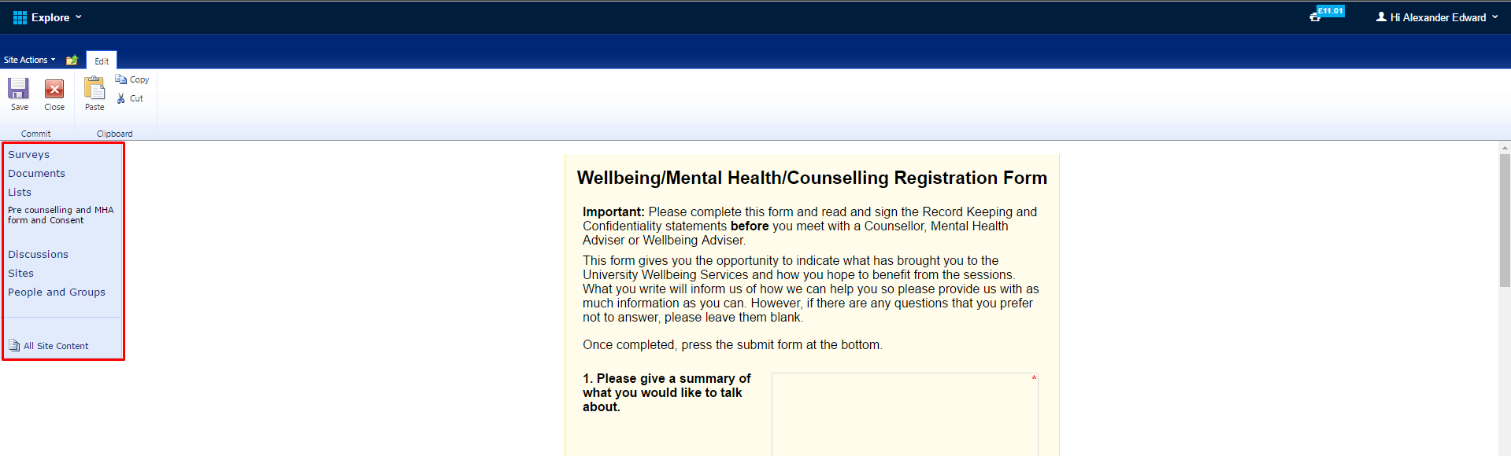

Source: (Birmingham City University, no date)

Figure 2 – Image showing sidebar not meant to be used by students

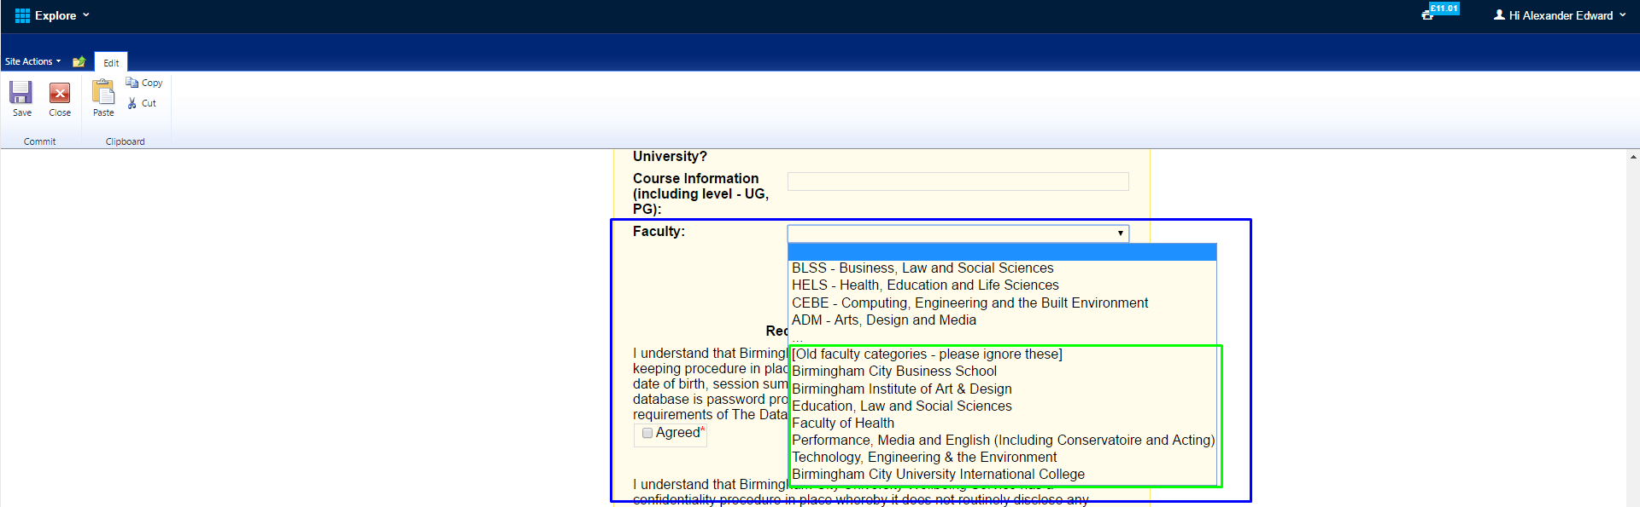

Source: (Birmingham City University, no date)

Figure 3 – Image showing question with unusable answers

## Product

Figure 4 shows the three different sections of the app that users can interact with. The app will communicate with an online database to allow the input of data such as appointments and allow access to the forum, this has been shown with the database section holding three tables for the appropriate app areas.

The main referral section of the app will contain a user creation page where users will be required to create their own account for the service. This account implementation is for the forum and so that the student can create appointments with Mental Health and Wellbeing Advisors. Although there is a possibility for me to use the university’s single sign on service in future, I have decided that this is not a good idea for the current project as I would like to trial it on a select focus group and do not want to allow all students access to the app or the forum at this moment in time. There is the possibility in the future to implement the OpenAthens Single Sign-On service that most UK universities use. This would allow me to create a location specific, university specific experience for each user. Another reason for not requesting to the OpenAthens service is due to the time restriction within this project, there are several legal issues I would have to face and discuss with the service provider and this process would take longer than the allocated time I have for this project.



Figure 4 – Diagram of the three sections of the app and how a user could access the other sections of the app.

## Rationale

### Reasons for Project

Higher Education Institutions are seeing a common trend within first year students where around 6% of all first year entrants do not continue with their studies according to data from the Higher Education Statistics Agency. The Times Newspaper states

“Six per cent of first degree entrants aged under 21 who enrolled in 2013-14 did not continue their studies beyond their first year, according to data from the Higher Education Statistics Agency.”

(Havergal et al., 2016)

Many institutions have theorised that most non-continuation cases are cause by mental health issues such as anxiety and depression. To combat this ongoing issue, many universities have set-up counselling services for students suffering with mental health conditions. Although the number of cases is not known, many counselling services are reporting an increase in referrals as stated by Ann Macaskill:

“There are increasing concerns globally about the mental health of students. In the UK, the actual incidence of mental disturbance is unknown, although university counselling services report increased referrals.”

(Macaskill, 2013)

As these services are becoming available, I have noticed many issues with the referral system and knowledge of their existence within different university institutions. One common issue I have seen is that many students are aware how to get counselling support however the university’s website makes it rather difficult for the student to refer themselves to the support services available.

### Project Effects

This project will allow the ease of use for support services to be accessed and will also create the availability where many students who do not want staff intervention, via counselling etc., to be able to gain support from other students experiencing similar issues. There is the potential for any products created within this project to be used in a live environment where staff and students would actively use the system.

The forum section of the app can also ease the strain that most support services are experiencing. As the general public are becoming more confident talking about mental health issues, many people are coming forward with various mental health issues.

### Comparison of other possible solutions

A possible solution for this issue is a web based application that utilises HTML, PHP and SQL Databases. I have decided that this is not an appropriate solution as the system needs to be available to those who are not near a computer and using their mobile devices to access the internet. This can create an issue where data usage is limited therefore a solution that uses little to no mobile data is optimum for this project.

## Methodology

### Research Methods

To obtain the relevant information suitable for my project, I will be collaborating with the university’s Mental Health and Wellbeing team. As part of my research, I will interview members of staff from the wellbeing team and many students who suffer from mental health illnesses.

Although my project will work with students who are interested in the mental health and wellbeing of themselves and others, I will ensure that all data collected from these students is to be anonymised to prevent any confidential and sensitive information from being publicised.

I will also be conducting surveys in the form of a questionnaire. This will allow me to see what needs are required from the final product and what features students and staff would like from the system.

Throughout my research, I will only include active staff and students from Birmingham City University. This is due to my final product only being suitable for use within the university and will incorporate the use of staff and student identification numbers. I will ensure the eligibility of this group by requesting them to enter their university identification number when testing or using the app.

### Development Methodology

During development, I will incorporate the waterfall lifecycle software development technique. This is mainly due to many parts of the lifecycle will be suitable as the design of the application must be completed before the final creation of the app can be completed.

### Evaluation Methodology

I will evaluate my whole system by using my original research focus group of active staff and students at Birmingham City University. I will ask each participant to use the app for around 5 minutes then answer a series of questions in the form of a questionnaire or interview.

## Resources

### General Computing Equipment

As this project will primarily develop on Apple’s iOS platform, the general computing equipment required for use will be an Apple Macintosh computer and an iOS Smartphone. I will be using my personal smartphone for this project for the testing of the application and will be allowing participants who are evaluating the app to use my device.

### University Based Resources

My project will be designing and creating an application designed for Birmingham City University therefore I will be working with the university’s student services to obtain resources such as internal procedures, access to the current system and information about any previous systems the department has used.

I will also be requiring student participants for my project to assist me in my research. These participants will influence the design of this application and are able to suggest additional features or tell me that a specific feature of the app is not required. I will obtain participants from the university’s Mental Health Awareness society.

## Schedule

Figure 5 shows a Task Sheet for the whole of my project. I have allocated time for each section and broken each assignment down into different areas. It also includes which tasks need to be completed before I can begin any given task.

|  |  |  |  |  |  |
| --- | --- | --- | --- | --- | --- |
| Task Number | Task Name | Duration | Start | Finish | Predecessors |
| 0 | **Final Year Project** | **170 days?** | **Mon 26/09/16** | **Fri 19/05/17** |  |
| 1 | **Project Proposal and Ethics** | **32 days** | **Mon 26/09/16** | **Tue 08/11/16** |  |
| 2 | Confirm Deadline Timescales | 1 day | Mon 26/09/16 | Mon 26/09/16 |  |
| 3 | **Complete Project Proposal** | **32 days** | **Mon 26/09/16** | **Tue 08/11/16** |  |
| 4 | Complete Introduction and Background | 1 day | Mon 26/09/16 | Mon 26/09/16 |  |
| 5 | Complete Aim | 5 days | Mon 26/09/16 | Fri 30/09/16 | 4 |
| 6 | Complete Objectives | 5 days | Mon 03/10/16 | Fri 07/10/16 | 5 |
| 7 | Complete Product | 5 days | Mon 10/10/16 | Fri 14/10/16 | 6 |
| 8 | Complete Rationale | 5 days | Mon 17/10/16 | Fri 21/10/16 | 7 |
| 9 | Complete Methodology | 5 days | Mon 24/10/16 | Fri 28/10/16 | 8 |
| 10 | Complete Resources | 5 days | Mon 31/10/16 | Fri 04/11/16 | 9 |
| 11 | **Complete Ethics Questionnaire** | **2 days** | **Sat 05/11/16** | **Tue 08/11/16** |  |
| 12 | Part 1 (Self-Assessment) | 1 day | Sat 05/11/16 | Mon 07/11/16 |  |
| 13 | Part 2 (Ethical Issues Form) | 1 day | Tue 08/11/16 | Tue 08/11/16 | 12 |
| 14 | Submit Project Proposal | 0 days | Tue 08/11/16 | Tue 08/11/16 | 3 |
| 15 | **Critical Literature Review** | **30 days** | **Wed 09/11/16** | **Tue 20/12/16** | **1** |
| 16 | Find Research Articles | 5 days | Wed 09/11/16 | Tue 15/11/16 |  |
| 17 | **Write Literature Review** | **24 days** | **Wed 16/11/16** | **Mon 19/12/16** |  |
| 18 | Introduction | 4 days | Wed 16/11/16 | Mon 21/11/16 | 16 |
| 19 | Overview of Literature | 4 days | Tue 22/11/16 | Fri 25/11/16 | 18 |
| 20 | Critical Comparison | 4 days | Mon 28/11/16 | Thu 01/12/16 | 19 |
| 21 | Conclusions | 4 days | Fri 02/12/16 | Wed 07/12/16 | 20 |
| 22 | References | 4 days | Thu 08/12/16 | Tue 13/12/16 | 21 |
| 23 | Glossary | 4 days | Wed 14/12/16 | Mon 19/12/16 | 22 |
| 24 | Submit Critical Literature Review | 0 days | Tue 20/12/16 | Tue 20/12/16 | 17 |
| 25 | **Project Research and Design** | **98 days** | **Mon 26/09/16** | **Wed 08/02/17** |  |
| 26 | **Current System Analysis** | **69 days** | **Mon 26/09/16** | **Thu 29/12/16** |  |
| 27 | Focus Groups | 10 days | Tue 08/11/16 | Mon 21/11/16 |  |
| 28 | Staff Interviews | 10 days | Mon 21/11/16 | Fri 02/12/16 |  |
| 29 | Questionnaires | 20 days | Fri 02/12/16 | Thu 29/12/16 |  |
| 30 | Obtain Current Referral Process | 5 days | Mon 26/09/16 | Mon 26/09/16 |  |
| 31 | **Requirement Specification** | **12 days** | **Mon 26/09/16** | **Tue 11/10/16** |  |
| 32 | **Feasibility Study** | **12 days** | **Mon 26/09/16** | **Tue 11/10/16** |  |
| 33 | Technological Feasibility | 2 days | Mon 26/09/16 | Tue 27/09/16 |  |
| 34 | Economic Feasibility | 2 days | Wed 28/09/16 | Thu 29/09/16 | 33 |
| 35 | Social Feasibility | 2 days | Fri 30/09/16 | Mon 03/10/16 | 34 |
| 36 | Legal Feasibility | 2 days | Tue 04/10/16 | Wed 05/10/16 | 35 |
| 37 | Operational Feasibility | 2 days | Thu 06/10/16 | Fri 07/10/16 | 36 |
| 38 | Timescale | 2 days | Mon 10/10/16 | Tue 11/10/16 | 37 |
| 39 | **New System Design** | **29 days** | **Fri 30/12/16** | **Wed 08/02/17** | **26** |
| 40 | Data Flow Diagrams | 3 days | Fri 30/12/16 | Tue 03/01/17 |  |
| 41 | UML Diagrams | 4 days | Wed 04/01/17 | Mon 09/01/17 | 40 |
| 42 | UI Design | 6 days | Tue 10/01/17 | Tue 17/01/17 | 41 |
| 43 | Database Design | 3 days | Wed 18/01/17 | Fri 20/01/17 | 42 |
| 44 | Validation and Form Design | 6 days | Mon 23/01/17 | Mon 30/01/17 | 43 |
| 45 | **Design Specification** | **7 days** | **Tue 31/01/17** | **Wed 08/02/17** | **44** |
| 46 | Platform and Software Design | 1 day | Tue 31/01/17 | Tue 31/01/17 |  |
| 47 | Input/output Design | 1 day | Wed 01/02/17 | Wed 01/02/17 | 46 |
| 48 | Data Structure Design | 1 day | Thu 02/02/17 | Thu 02/02/17 | 47 |
| 49 | Process Design | 1 day | Fri 03/02/17 | Fri 03/02/17 | 48 |
| 50 | Interface Design | 1 day | Mon 06/02/17 | Mon 06/02/17 | 49 |
| 51 | Testing and Installation Plan | 2 days | Tue 07/02/17 | Wed 08/02/17 | 50 |
| 52 | **Product Development** | **60 days** | **Thu 09/02/17** | **Wed 03/05/17** | **45** |
| 53 | **New System Development** | **55 days** | **Thu 09/02/17** | **Wed 26/04/17** |  |
| 54 | **Referral Section** | **12 days** | **Thu 09/02/17** | **Fri 24/02/17** |  |
| 55 | Create Data Structures | 2 days | Thu 09/02/17 | Fri 10/02/17 |  |
| 56 | Create User Interfaces | 4 days | Thu 09/02/17 | Tue 14/02/17 |  |
| 57 | Link Data Structures to User Interface | 10 days | Mon 13/02/17 | Fri 24/02/17 | 55 |
| 58 | **Appointment Section** | **12 days** | **Mon 27/02/17** | **Tue 14/03/17** | **54** |
| 59 | Create Data Structures | 2 days | Mon 27/02/17 | Tue 28/02/17 |  |
| 60 | Create User Interfaces | 4 days | Mon 27/02/17 | Thu 02/03/17 |  |
| 61 | Link Data Structures to User Interface | 10 days | Wed 01/03/17 | Tue 14/03/17 | 59 |
| 62 | **Forum Section** | **12 days** | **Wed 15/03/17** | **Thu 30/03/17** | **58** |
| 63 | Create Data Structures | 2 days | Wed 15/03/17 | Thu 16/03/17 |  |
| 64 | Create User Interfaces | 4 days | Wed 15/03/17 | Mon 20/03/17 |  |
| 65 | Link Data Structures to User Interface | 10 days | Fri 17/03/17 | Thu 30/03/17 | 63 |
| 66 | **Administration Area** | **12 days** | **Fri 31/03/17** | **Mon 17/04/17** | **62** |
| 67 | Create Data Structures | 2 days | Fri 31/03/17 | Mon 03/04/17 |  |
| 68 | Create User Interfaces | 4 days | Fri 31/03/17 | Wed 05/04/17 |  |
| 69 | Link Data Structures to User Interface | 10 days | Tue 04/04/17 | Mon 17/04/17 | 67 |
| 70 | **System Guides** | **7 days** | **Tue 18/04/17** | **Wed 26/04/17** |  |
| 71 | Creation of User Guide | 7 days | Tue 18/04/17 | Wed 26/04/17 | 54,58,62,66 |
| 72 | Creation of Administration Guide | 4 days | Tue 18/04/17 | Fri 21/04/17 | 54,58,62,66 |
| 73 | **New System Testing** | **5 days** | **Thu 27/04/17** | **Wed 03/05/17** | **53** |
| 74 | Work Through System Test Plan | 5 days | Thu 27/04/17 | Wed 03/05/17 |  |
| 75 | **Evaluation Process** | **15 days** | **Thu 27/04/17** | **Wed 17/05/17** | **53** |
| 76 | Questionnaires | 10 days | Thu 27/04/17 | Wed 10/05/17 |  |
| 77 | Focus Groups | 2 days | Thu 11/05/17 | Fri 12/05/17 | 76 |
| 78 | Staff Interviews | 5 days | Thu 11/05/17 | Wed 17/05/17 | 76 |
| 79 | **Final Project Report** | **109 days** | **Tue 20/12/16** | **Fri 19/05/17** |  |
| 80 | **Initial Pages** | **7 days** | **Tue 20/12/16** | **Wed 28/12/16** |  |
| 81 | Title Page | 1 day | Tue 20/12/16 | Tue 20/12/16 |  |
| 82 | Abstract | 2 days | Tue 20/12/16 | Wed 21/12/16 |  |
| 83 | Dedication | 2 days | Wed 21/12/16 | Thu 22/12/16 |  |
| 84 | Table Of Contents | 1 day | Thu 22/12/16 | Thu 22/12/16 |  |
| 85 | Table Of Tables | 4 days | Fri 23/12/16 | Wed 28/12/16 |  |
| 86 | Table Of Figures | 4 days | Fri 23/12/16 | Wed 28/12/16 |  |
| 87 | **Report Chapters** | **83 days** | **Tue 20/12/16** | **Thu 13/04/17** |  |
| 88 | Introduction | 11 days | Tue 20/12/16 | Tue 03/01/17 |  |
| 89 | Literature Review | 11 days | Mon 02/01/17 | Mon 16/01/17 |  |
| 90 | Background Research | 11 days | Fri 13/01/17 | Fri 27/01/17 |  |
| 91 | Requirements | 11 days | Thu 26/01/17 | Thu 09/02/17 |  |
| 92 | Implementation | 11 days | Wed 08/02/17 | Wed 22/02/17 |  |
| 93 | Testing | 11 days | Tue 21/02/17 | Tue 07/03/17 |  |
| 94 | Evaluation Of Product | 11 days | Mon 06/03/17 | Mon 20/03/17 |  |
| 95 | Evaluation Of Process | 11 days | Fri 17/03/17 | Fri 31/03/17 |  |
| 96 | Conclusions | 11 days | Thu 30/03/17 | Thu 13/04/17 |  |
| 97 | **Final Pages** | **27 days** | **Thu 13/04/17** | **Fri 19/05/17** |  |
| 98 | References | 5 days | Thu 13/04/17 | Wed 19/04/17 |  |
| 99 | Bibliography | 6 days | Thu 13/04/17 | Thu 20/04/17 |  |
| 100 | Appendices | 10 days | Thu 20/04/17 | Wed 03/05/17 |  |
| 101 | Submit Final Project Report | 0 days | Fri 19/05/17 | Fri 19/05/17 |  |
| 102 | **Project Presentation** | **99 days** | **Tue 20/12/16** | **Fri 05/05/17** |  |
| 103 | Create Project Presentation | 40 days | Tue 20/12/16 | Mon 13/02/17 |  |
| 104 | Test Presentation Equipment | 1 day | Tue 20/12/16 | Tue 20/12/16 |  |
| 105 | Deliver Project Presentation | 0 days | Mon 24/04/17 | Mon 24/04/17 |  |

Figure 5 – Table Showing Project Task List.

# References

Apple Inc (2016) IOS human interface guidelines. Available at: https://developer.apple.com/ios/human-interface-guidelines/ [Accessed 3 October 2016].

Birmingham City University (2015) Mental Health and Wellbeing. Available at: ​ https://icity.bcu.ac.uk/student-services/Health-and-Wellbeing/Mental-Health-and-Wellbeing [Accessed 27 October 2016].

Birmingham City University (no date) Wellbeing/Mental Health/Counselling Registration Form. Available at: https://hub.bcu.ac.uk/sites/ss/HW/Lists/Pre%20counselling%20and%20MHA%20form%20and%20Consent/Item/newifs.aspx?List=dac1e7ab-7044-42e1-9597-d7ecb809e3bf&Web=c45b5557-f4af-4bae-bbc9-bd2a1b010293 [Accessed 1 November 2016].

Havergal, C. and The Times Higher Education (2016) Rise in UK university dropout rate ‘disappointing’. Available at: https://www.timeshighereducation.com/news/rise-uk-university-dropout-rate-disappointing [Accessed 4 November 2016].

Macaskill, A. (2013) The mental health of university students in the United Kingdom. British Journal of Guidance & Counselling, 41(4), pp. 426–441. Available at: http://dx.doi.org/10.1080/03069885.2012.743110.

Nami, Y., Nami, M. S. and Eishani, K. A. (2014) The students’ mental health status. Procedia - Social and Behavioral Sciences, 114, pp. 840–844. Available at: http://dx.doi.org/10.1016/j.sbspro.2013.12.794.